# **4h_mark1_em_copy_1Image result for msu extensionGetting Started with the**

# **Michigan 4-H State Awards**

# **Group Application**

(4-H Members 13-19 years old)





Networking

Achievement

Career Skills

Workforce Preparation

The Michigan 4-H State Awards Program provides 4-H members a learning experience where they can develop career skills by using your 4-H experiences to compile a portfolio similar to a professional application while receiving recognition for their 4-H involvement. The application process will help you build your skills in communication, literacy, record keeping, and marketable skills. The application will require you to reflect on your past 4-H experiences and provide thoughtful responses. 4-H State Awards recognize youth for their engagement and learning in the 4-H program, focusing on the skills they have gained; not necessarily the past achievements and awards received. Once completed, your portfolio may be a useful tool that can be referenced when completing future job, college, or scholarship applications.



Research by the National Association of Colleges and Employers indicates that employers are seeking college graduates for entry-level positions with the following soft skills:

* Ability to verbally communicate with persons inside and outside the organization
* Ability to make decisions and solve problems
* Ability to obtain and process information
* Ability to plan, organize, and prioritize work
* Ability to analyze quantitative data
* Technical knowledge related to the job
* Proficiency with computer software programs
* Ability to create and/or edit written reports
* Ability to sell or influence others

The 4-H State Award Program seeks to recognize Michigan’s top 4-H members. 4-H members should find this experience challenging, but also rewarding. There are minimum quality standards in place throughout the process to encourage 4-H members to put forward their best effort and hold themselves to high expectations.

**The Group 4-H State Awards Experience**

A 4-H group may be represented by 2-5 members of the group who complete the application on behalf of the group and represent the group during the 4-H State Awards Program during 4-H Exploration Days. 4-H members representing the group must be 13-19 years old. The group representatives prepare and submit the Group 4-H State Award application together. Up to 12 groups may be named State Awards finalists and be invited to be recognized at the 4-H State Awards Celebration during 4-H Exploration Days. 4-H State Award finalists are encouraged to attend 4-H Explorations Days, where they will select from over 100 sessions to attend during the event.

Groups will present for the selection committee in early June through video conference (Zoom) from the groups’ local MSU Extension office. While face-to-face interviews are valuable, many companies are moving in the direction of screening potential employees through first round virtual interview; utilizing this approach, finalists will have the opportunity to fully participate in 4-H Exploration Days.

The 4-H State Awards Celebration will be held on Wednesday afternoon of 4-H Exploration Days where delegates will be recognized in front of peers following the welcome and keynote speaker.

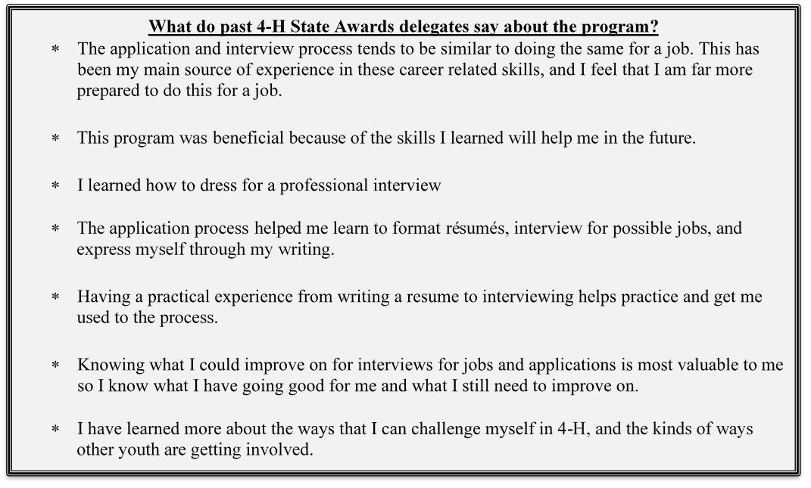

**Preparing Your Application**

It is strongly encouraged to begin working on your application early, as it will take you time to complete it and have it reviewed before submitting it. This is a great opportunity to build your skills in goal setting and time management. Please be sure to communicate with your county 4-H Program Coordinator early in the application process. All applications are due by **April 1st**. Your completed application will be uploaded through the MSU Extension Events Registration system: <https://events.anr.msu.edu/StateAwards24/>

This document will provide you with a brief overview of the application. To find complete information about the Michigan 4-H State Awards Program, including the guidelines for writing your application, the selection process, and other important details, view the Overview and Instructions document at: **<https://www.canr.msu.edu/4_h_scholarships_and_recognition_program/4-h-awards-and-recognition-program/youth-recognition>**

Portions or entire submissions may be posted on the Michigan 4-H section of the MSU Extension website and promoted digitally in newsletters and social media.

Your 4-H State Award application will be submitted as one complete Word Document containing the following pages in this order. Although the guidelines indicate maximum word counts, there is not a minimum word count for each response; however, you are encouraged to use at least ½ of the allowable space. Remember, this is the judges’ only opportunity to learn about you and your project; your goal is to show them why you deserve this award.

* **Section 1:** Cover Letter (1 page, Maximum 500 words; do not title/label this page)
* **Section 2:** Résumés (2-5 pages, depending on number in your group; maximum 1 page each representative of the group. Do not title/label this page)
* **Section 3:** 4-H Experience and Impact Story (4-9 pages, depending on number in your group; see Overview and Instructions document for directions to write your story. Parts 1, 2, 3, and 4 maximum 2,000 words total: plus 300 words for each representative part 5)
* **Section 4:** Application Questions (6-14 pages, depending on number in your group)  
  For the following questions, include only information that relates to the 4-H group award. Groups should answer the application questions from a group perspective unless otherwise noted, with emphasis on skill development in a group dynamic. See Overview and Instructions document for examples.Limit your response to no more than 500 words for each question unless otherwise noted; begin a new page for each question. Include the question in your application prior to your response.

1. Identify up to four areas of content/project knowledge your group learned in your 4-H project and describe what you have learned and how you learned it.
2. Choose four life skills from the diagram (one from each of Head, Heart, Hands, and Health) and describe how your group has learned each life skill through your 4-H group experience.
3. Describe how your group has used any one life skill (from the diagram) in your 4-H experience.
4. Identify up to three 4-H citizenship and/or community service experiences your group has had and describe their significance to you, your group, or your community.
5. Each representative of your group (300 words for each representative)—Describe how you have or will apply skills learned in a team setting to a life situation outside of 4-H.
6. Each representative of your group (300 words for each representative)—Identify one 4-H leadership experience you have had and describe its significance to your personal growth and development.

* **Section 5:** Group Biography (Maximum 150 words; Write a biography (in third person) that summarizes your application, goals, and 4-H involvement. This summary will be used to introduce award winners during the 4-H State Awards Recognition Celebration)

The following information (for each group representative) will be requested in the Events Management system when you submit your application. You will upload your final award application and photo through the Events Management platform. Be sure to have all the information and your attachments ready when you submit your application.

Name:

Address:

City: State: Zip:

Home Phone:

Email address:

County (where you are enrolled):

Years in 4-H: Grade in School: Age (as of January 1, 2024):

Name of 4-H Club or Group (can list more than one):

Receiving a Michigan 4-H State Award is a prestigious honor. As such, it is encouraged that your application reflects your best work and represents you in a professional manner. It is recommended that you have your application reviewed by others (peers, parents, teachers, 4-H leaders, etc.) prior to final editing and submission.

Please list your reviewers:

A copy of your application will be emailed to your county’s 4-H Program Coordinator and your 4-H leader to verify accuracy. Enter their information below.

4-H Program Coordinator’s Name:

4-H Program Coordinator’s Email:

4-H Leader's Name:

4-H Leader’s Email:



Figure 1. Hendricks, P.A. (1996).*Targeting Life Skills Model: Incorporating Developmentally Appropriate Learning Opportunities to Assess Impact of Life Skill Development*. Ames: Iowa State University Extension and Outreach.