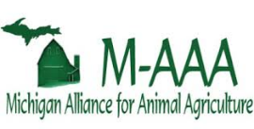
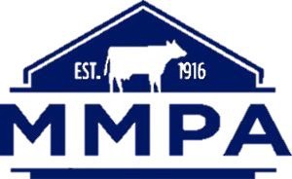
2019 Corn Silage Mycotoxin Survey

Please submit a corn silage sample for mycotoxin testing (26 different toxins) to MSU Agronomy lab (Manni Singh, 517-775-8174, msingh@msu.edu, 4450 Beaumont Road, Lansing 48910).
Goal: Investigate the relative impacts of agronomic practices and weather conditions across Michigan locations on mycotoxin contamination and overall corn silage quality
Procedure: Collect a representative sample during harvest (take multiple samples from the field, mix well and then collect a 1 lb. subsample), sample should preferably be dried (if possible) or frozen soon after collection and either will be picked up by the lab or can be shipped in before end-November (lab will pay shipping costs). We will share data on mycotoxin and quality (NIRS) with you. Please fill out the information requested below when time permits (preferably by Dec 31). Your personal information will stay confidential.
Name:_____________________________Contact:__________________________________
Field Name/ID:
Field Location (including GPS): Acres:

Has this field had issues with mycotoxins in the past?
Yes/No/Unknown

Irrigation
Yes/No

Field Drainage
Yes/No
Type_____________
Crop History
Rotation:
2018 Crop
2017 Crop
2016 Crop
Cover Crops (if any):_______________________________________
2019 Field Season
Planting Date: Harvest Date/moisture%:
Corn Hybrid: Seeding rate:
Tillage:
Spring/Fall Equipment used:______________________
Nutrient Management Program:
Manure: Yes/No. Amount__________________
Lime: Yes/No. Amount__________________

Fertilizer
 | Date | Analysis | Rate
Broadcast

Starter

Side Dress

Other

Herbicide Program
Date: Product: Rate:
Date: Product: Rate:
Date: Product: Rate:
Insecticide Program
Date: Product: Rate:
Date: Product: Rate:
Fungicide Program
Seed Treatment:
Foliar Fungicide:
Date: Product: Rate:
Additional Information
Soil test (ppm). pH____P______K______OR please provide a soil test report if available.
Weather Station on farm? Yes/No
Ear or stalk rot observed in field this year?
Insect (e.g. western bean cutworm/corn borer/earworm) feeding?
Other relevant information

___

