Systems, Communities, Society and Values¹

A system is something with two or more interactive parts. Systems evolve and subsequently become extinct. During this process, systems (including communities and societies) undergo three phases: development, dynamic equilibrium at maturity and senescence (Fig. 1). Human communities consist of individuals sharing common values. For a community to be successful on a long-term basis, the process of development must include bringing the system to a fuller or better state. This requires moral/ethical value judgments related to overall quality of human life.

During the past two centuries, dynamic equilibrium has been impacted significantly by Adam Smith's Wealth of Nations (1776) and Karl Marx/Frederich Engels' Communist Manifesto (1848). In the 21st Century, it can be argued that these socio-economic philosophies resulted in both desirable and non-desirable consequences. The objective of Micro-Essay No. 91 is to use the language of ecology to describe these system responses and present an alternative philosophy. The alternative is designed to foster a high quality of life for the vast majority of the 7.2+ billion people of the global ecosystem, a place where living organisms interact with their non-living environment. The term, ecosystem, was first used in the scientific literature in 1935 (Tansley). Three years earlier, von Bertalanaffy published the foundation for his future General Systems Theory (1969). In a world that is circa five billion-years-old, these are very recent events.

The ecological processes of competition, predation and mutualism function as system regulators. Excessive competition can be detrimental to the competitors and the rest of society. Non-regulated predation results in significant quality of life disparities. Mutualism, without positive persuasion, leads to apathy. Collapse is the end-point of growth (the quantitative process of increasing in size). The Law of Conservation of Matter mandates that the process of maximization will harm one or more components of the system. These characteristics are often in significant conflict with the fundamental common values of community. Unfortunately, this often results in alienation of individuals and complete sectors of society.

The need for societal implementation and stabilization of shared values mandates government. In 2015, government must be based on systems of close to real-time feedback used for shared value decision making related to local and regional issues. Without this property, the process of senescence is catalyzed. For example, the City of Detroit reached grandeur in 1950, with a population of 1.8+ million. Unfortunately, this was based totally on a monoculture, the automotive industry. Five years later, with the closure of the Packard Plant (Fig. 2), the initial stages of senescence were already well entrenched. Today, Detroit has a population of less than 700,000 and is a classical example of collapse. In many ways, Detroit reminds me of the evidence of collapse I have witnessed during the last ten years in my travels in former Soviet Republics throughout Central Asia (Figure 3). Dr. Seuss' Lorax provides a comprehensive description of the predation (Once-ler Family) monoculture (Truffala Tree)-induced collapse; whereas, the demise of the Soviet Union is an example of the shortcomings of mutualism.

Figure 2. Packard Plant Detroit, Michigan (2014)

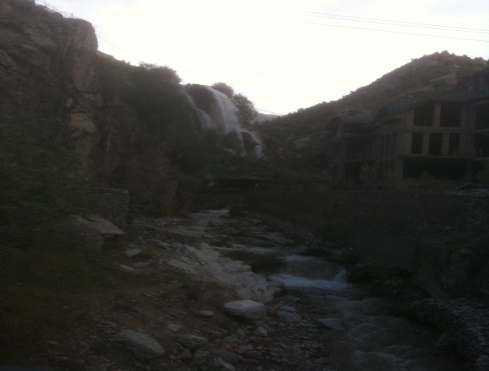
Figure 3. Former Industrial Plant, Tajikistan (2011)

Throughout history, conflicts among humans have resulted from the lack of shared values and competition for limited natural resources. When my great grandmother Bird, as a young child and moved across southern Kansas with her parents in their covered wagon, the land was rich and there were many open spaces. Four decades later, when my father migrated east, just before the Great U.S. Dust Bowl, the native short grass prairie ecosystem had been destroyed and there was far less room at the inn. During my lifetime (>75 years), war has been the norm. In an era of rapid global mass transportation and instant cyber communications, it is imperative for society to develop and adopt social systems based on fundamentals other than competition, predation and mutualism. It is my recommendation that these should be based on Meadows, Meadows and Randers' concept of True Development: the qualitative process of bringing systems to fuller or better states (1992). This activity mandates close to real-time moral/ethical value judgments. The concept of Economics as a Moral Science was described by Kenneth Boulding in his 1967 Presidential Address to the American Economic Society (Boulding, 1969). It can be hypothesized that activities associated with important and powerful sectors of humanity, have resulted in a divergence of Homo sapiens into two social subspecies (Fig. 4). It is imperative, that in the near future, these converge as Homo humanicus. For this to take place, it will be necessary to develop local systems of government based an ethical concept of True Development and Economics as a Moral Science.

The current dominant hypothesis is that global human population will peak at circa 9 billion in 2050. As a scientist, I must ask, what is the alternate hypothesis? Could it be 3 billion, the global population density that existed in 1961, the year I was graduated from college? This alternative hypothesis does not paint a very desirable picture for my children and grandchildren, and those of all peoples of the world. Do we know the earth's or even local community carrying capacities for a reasonably high quality of human life? While living systems are basically self-regulating, it is the responsibility of H. humanicus to assure a set of common values that are in the best interests of the vast majority of the world's local communities. This must include the global eco-literacy necessary to know what to do with the remaining Truffala seeds and how to manage the resulting primary productivity (green plant biomass) and associated heterotrophs in a positive sustainable manner. For this is the way the world is known to work in regards to humankind.

Homo economicus Race clodiensis
Homo sapiens Homo humanicus
Homo heroicus Race foolynchus

Figure 4. Dynamics of the divergent evolution of Homo sapiens and desired convergent future state, Homo humanicus in a world of 7.2+ billion (based, in part, on Economics as a Moral Science by K. Boulding).

________________________________________________________________

¹Micro-Essay No. 91 (December 31, 2014)
George W. Bird, Department of Entomology, Michigan State University
East Lansing, Michigan, USA, 48824, soilhealthbiology@gmail.com

²References
-Bertalanaffy. L. von. 1969. General Systems Theory. George Braziller, New York. 295 pp.
-Boulding, K. 1969. Economics as a Moral Science. American Economic Review, Vol. 59:1-12.
-Marx, K. and F. Engles. 1848 (1964 English edition), The Communist Manifesto. Simon & Schuster, New York.
-Meadows, D., D. Meadows and J. Randers. 1992, Beyond the Limits. Chelsea Green. White River Junction, VT.
-Seuss, D. 1971. The Lorax. Random House. New York.
-Smith, A. 1776 (1976 edition). The Wealth of Nations. Univ. Chicago Press, Chicago. 568 pp.
-Tansley, A. 1935. The use and abuse of vegetational concepts and terms. Ecology 16: 283-307.

