**Ingham County 4-H Council**

**‘Head & Heart’ Award and/or County Medal**

**Application**

Name:___________________________________

Years in 4-H (including cloverbud)_______________

Address:____________________________________

City/State/Zip:_______________________________

Phone:_____________

Parent/Youth Emails:____________________________________________________

4-H Age (As of January 1)__________ Birthdate: _______________

Grade in School:_______ School attending:___________________

Club:______________________________________

Community Leader:____________________________________

Community Leader Signature:____________________________

Awards applying for: Please specify project areas for county medals:

* County Medal(s): __________________________________________________
* Head and Heart Award

**County Medal Applicants:**

1. Select up to three project areas for the Awards Committee to consider. (The Committee may select you for a project area that you did not choose, if appropriate.)
2. Complete the application form and write the required essays.
3. The completed form is due by midnight (if emailing) or by 5pm (if submitting a paper copy) on November 3rd to [weissgle@msu.edu](mailto:weissgle@msu.edu)

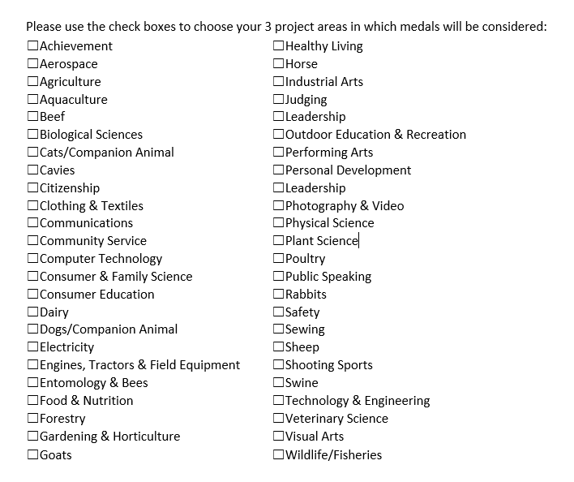



**For the following four (4) questions, share information that relates to your County Medal project areas, or Head & Heart Award for which you wish to be recognized. Limit your response to no more than 400 words for each question. Please attach your responses in essay form.**

1. **Choose four life skills from the diagram and describe how you have developed each life skill through your 4-H experience.**
2. **Identify up to four areas of content knowledge you have learned in your 4-H experience and describe what you have learned and how you learned it.**
3. **Identify up to two 4-H leadership experiences you have had and describe their significance to your personal growth and development.**
4. **Identify up to two 4-H citizenship/community-service experiences you have had and describe their significance to you and your community**

**COUNTY MEDAL APPLICANTS ONLY,**

**PLEASE COMPLETE THE FOLLOWING FIVE (5) QUESTIONS:**

List any offices held or roles you have played in your 4-H club:

List any County Medals or State Awards previously received:

Please list any Ingham County 4-H shows or workshops you have participated in over the past year. Please include your role in the event (participant, teen leader, organizer, etc)

List your most significant 4-H awards from any year, or other types of recognition within your chosen project areas:

List a couple non-4-H activities in which you participate and what you have achieved: