Approving Club/Unit Requests
Before You Start
Programs that allow families to add additional units/clubs after the member’s enrollment has been approved will find Unit/Club requests on the Enrollment tab, Unit/Club Requests screen.
Steps  - Click on the Enrollments tab in the navigation pane.  - Click the Unit Requests sub-tab.  - Click on the record to review the unit request. | Screenshots  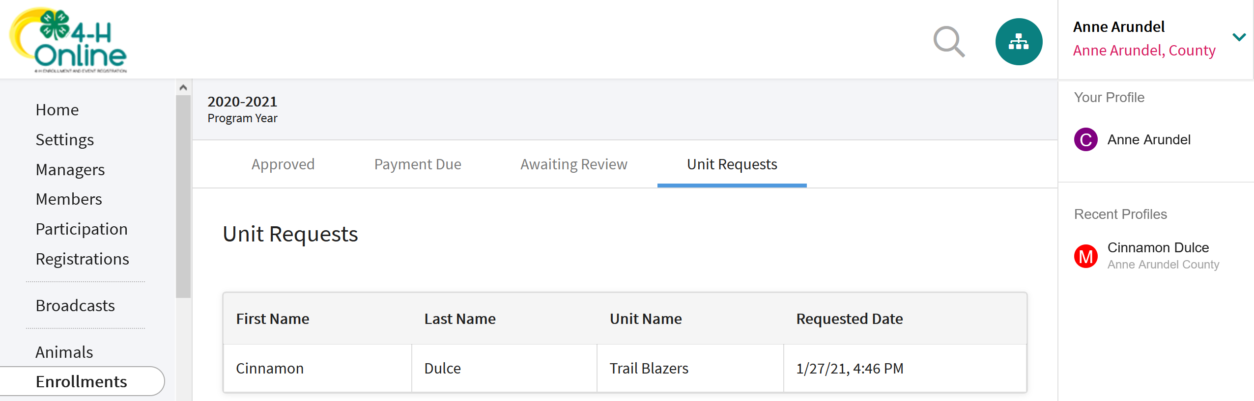  (Screen appearance may vary per state)
- Enter a comment (if necessary) and click Approve.  - Remember that if you want to associate this new club with the Member’s projects in a previous club, you will want to use the Swap Clubs option instead of deleting a previous club membership (deleting a club membership “loses” any projects associated with the club). | 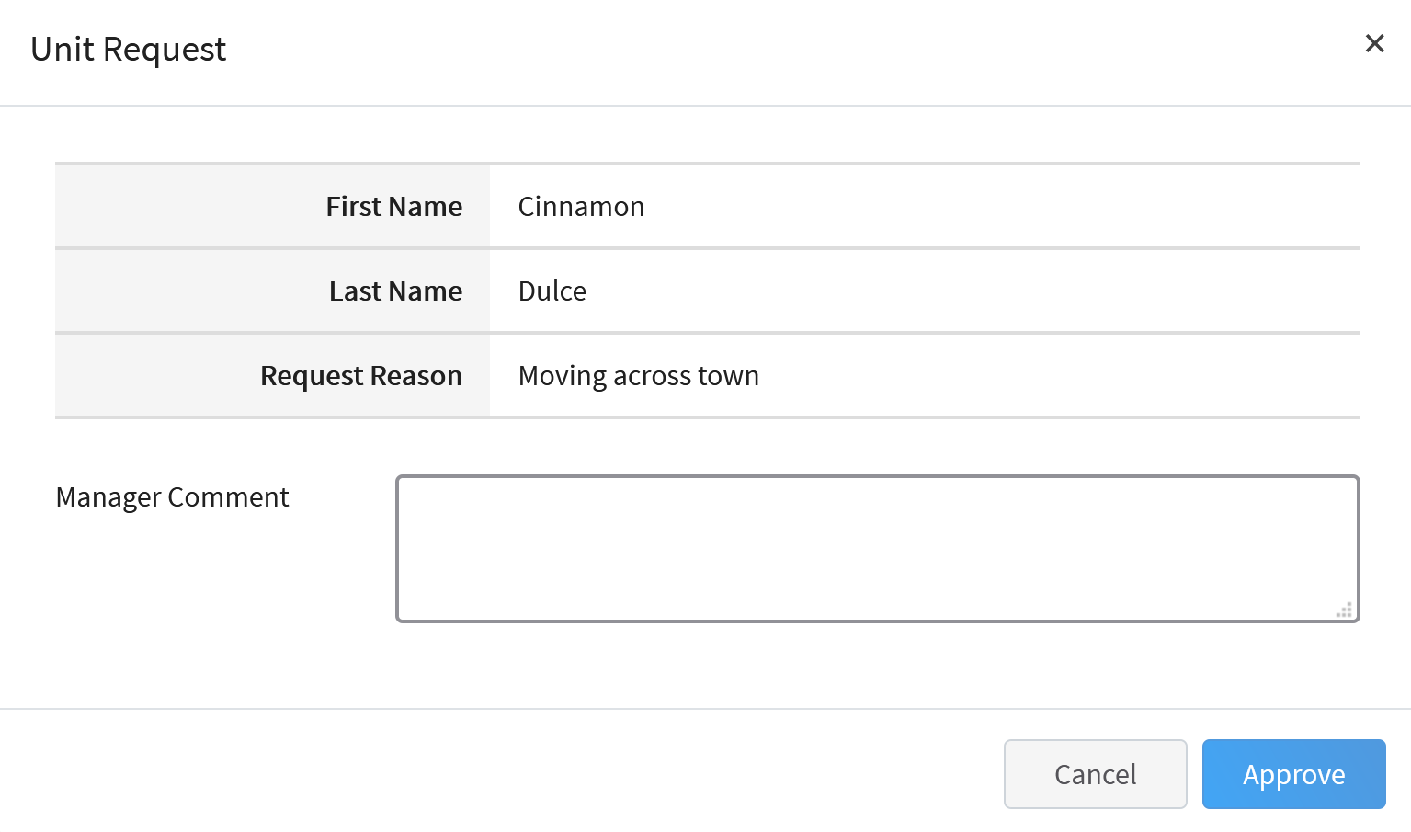
Tips
If a family has requested the club/unit change multiple times, and the club has already been added to the member’s enrollment by a manager (once), the remaining unit/club requests will not be removed from the screen upon the first approval.
- The club would need to be removed from the member’s enrollment before approving the duplicate unit/club request.
- Make note of any projects associated with the unit/club before removing the club from the enrollment. They will need to be added back to the enrollment once the last unit/club request is approved.

