Assigning Club/Unit Leader Permissions
Before You Start
Before a Club Leader can login, the manager must approve their enrollment and give them appropriate permissions. Typically, this is done by the County Manager, but can also be done by an Institution Manager.
Steps  - Log in to your Manager account.  - Click on the Units tab.  - Select the Club for which you would like to give a volunteer club leader permission to access. | Screenshots  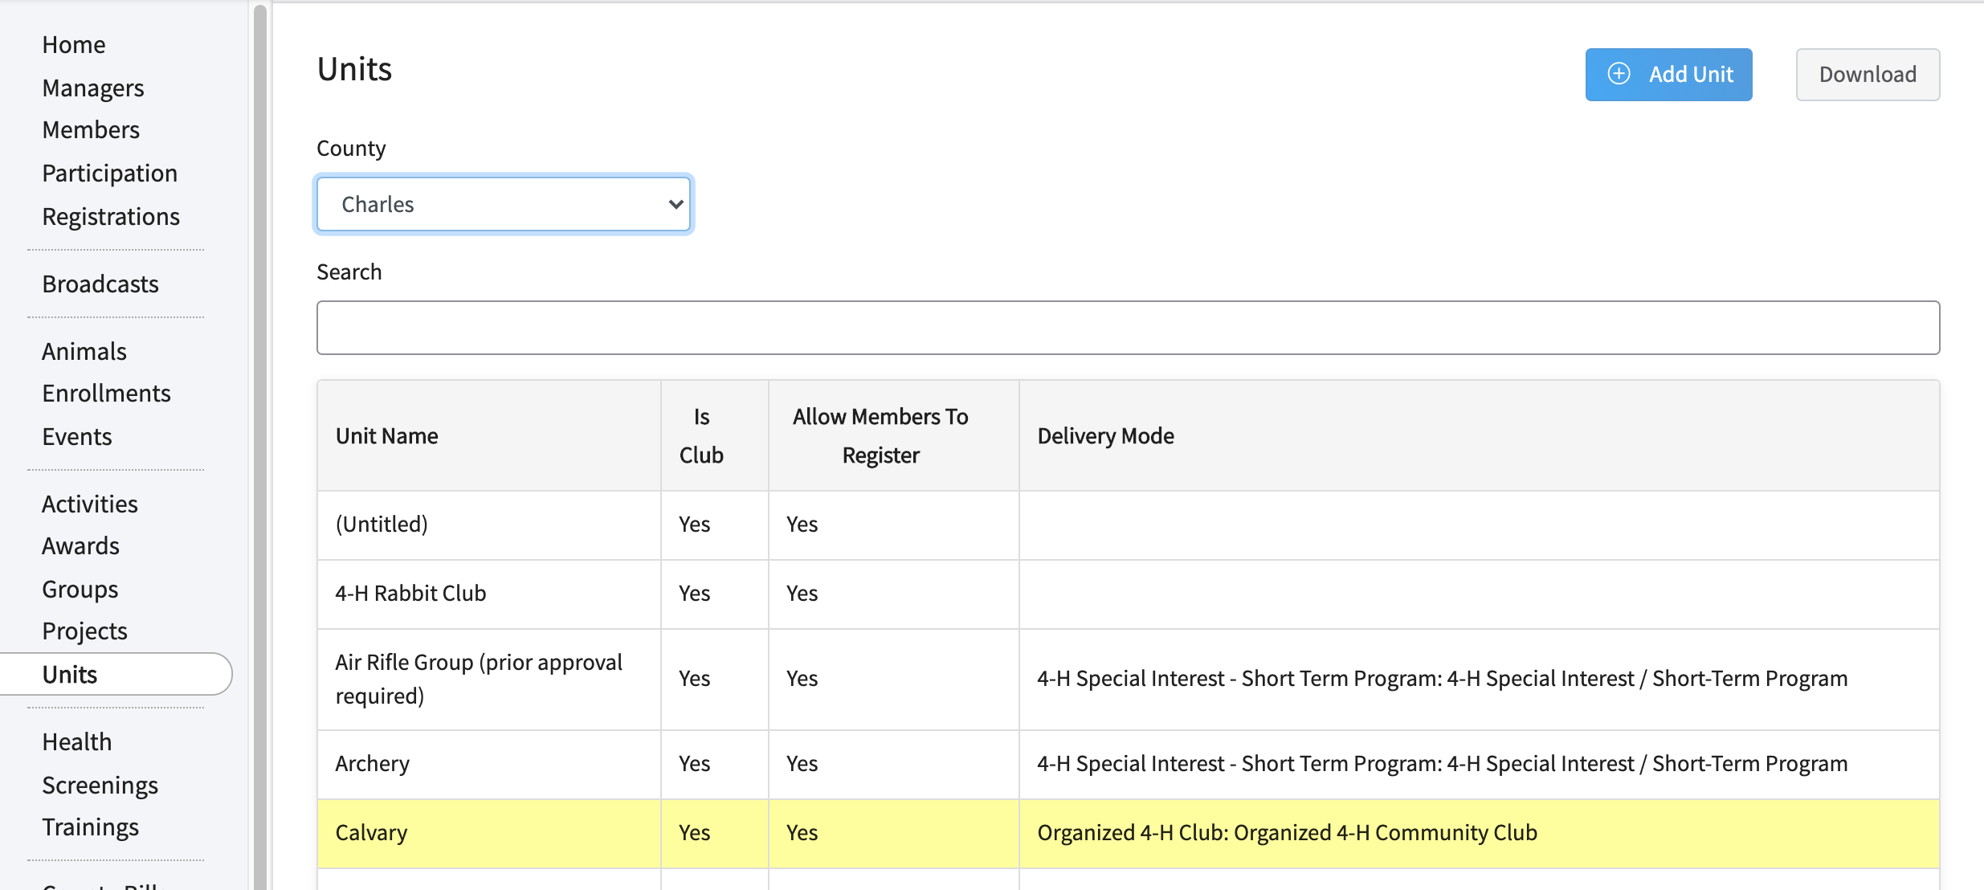  (Screen appearance may vary per state)
- Scroll down to the Unit Leaders section and click on the Leader’s name. | 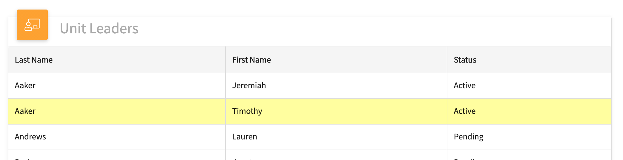
- Select the level of permissions you would like to give them.  - Leaders may download a roster. | 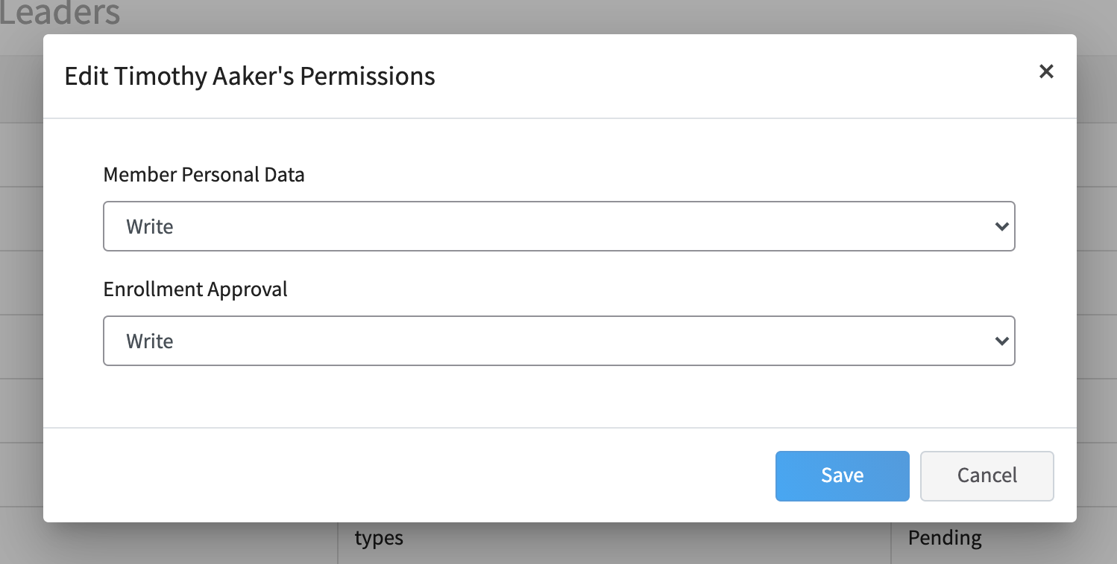
- Send the Leader Login (PIN) to the leader.  - See the Club Leader Login Help Sheet for instructions to give to Club Leaders.  - There is an option on the Club Details screen to regenerate the Leader Login in case of changes in Club leadership. For security purposes, this is an auto-generated password.  - If the program settings restrict Club Management to Institution Managers, then only the Institution Manager can reset the Leader Login Code. | 