Club Leader Login
Before You Start
As a Club Leader, your enrollment must have been approved, and permissions assigned before you can login to the club.
Steps  - Login to 4-H Online with your family’s 4-H Online email and password.  - Locate your name in the list of members in your family.  - Click the ‘View’ button next to your name. | Screenshots  (Screen appearance may vary per state)  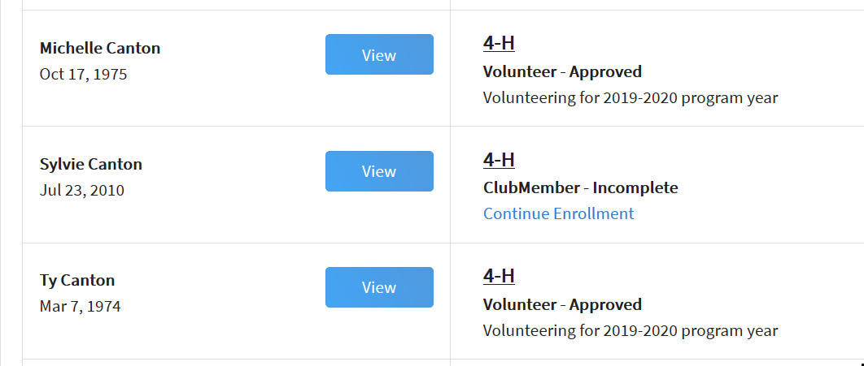
- Click on Clubs in the navigation pane on the left side of the screen.  - Click the Manage button for the Club. | 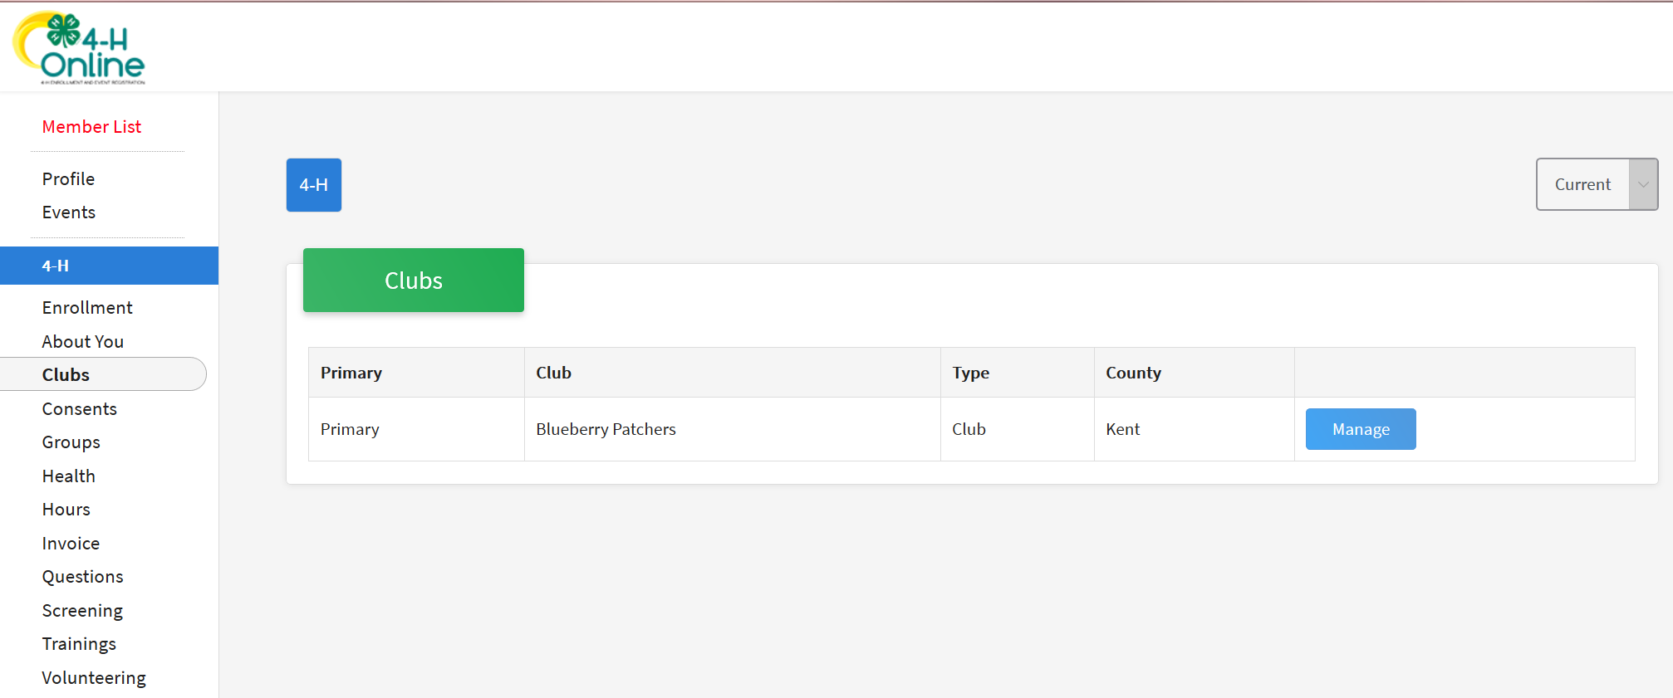
- Enter the Unit (Club) PIN provided to you by the county office.
- Click the Login button.
- You will be able to download the Club Roster for your Club. | 