Reviewing Enrollments
Before You Start
Member enrollments are reviewed by a County Manager in their Enrollment County (county of the member’s primary club/unit or the Family County if a volunteer is not enrolled in a club).
- Submitted enrollments may not be reviewed until the member has completed any required screenings and/or trainings associated with their role, volunteer type, or project selections.
- Volunteer Screening must be approved before the enrollment may be reviewed.
- Click on the Enrollments tab in the navigation pane.  - Click on the Awaiting Review sub-tab.  - The screen will list all enrollments that have been submitted.  - Hover over the symbol in the requirements column to see what is needed for the enrollment to become Active.  - Records that have an alarm clock symbol are ready to be reviewed. | Screenshots  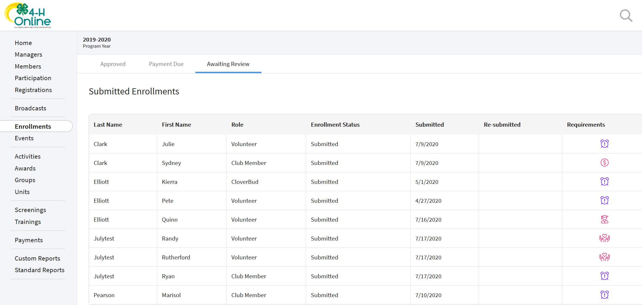  (Screen appearance may vary per state)
- Click on the member’s name to review their enrollment information.  - If applicable, click the Edit button for Other Questions to modify responses or enter responses for manager-only questions. (Required manager-only questions are only enforced if the Manager clicks Edit on the Questions section.)  - If applicable, upload any files as needed. These may be manager-only file uploads, or files uploaded by the member that need replaced.  - If applicable, click the edit button for the Invoice to apply a coupon code.  - If the enrollment will be returned to the member for corrections, please enter a comment for the user and click Send Back. The comment will be included in the email they receive to notify them that the enrollment has been returned.  - In the rare case that the member enrollment is to be Blocked and prevented from enrolling for the rest of the program year, click the Block button. This member will not be allowed to enroll. | 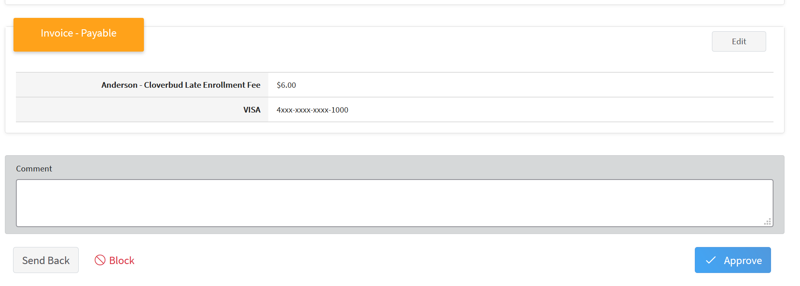  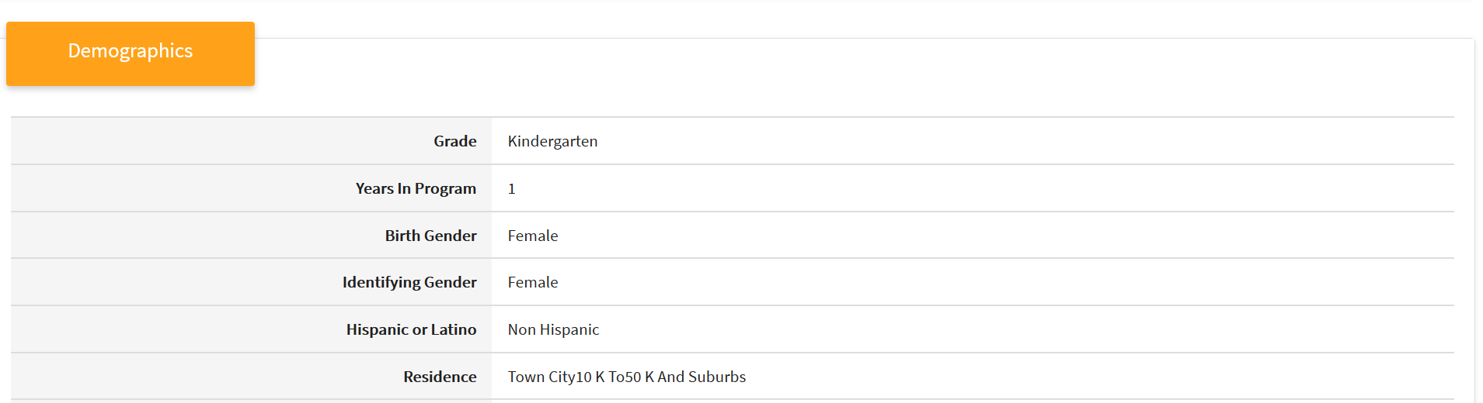  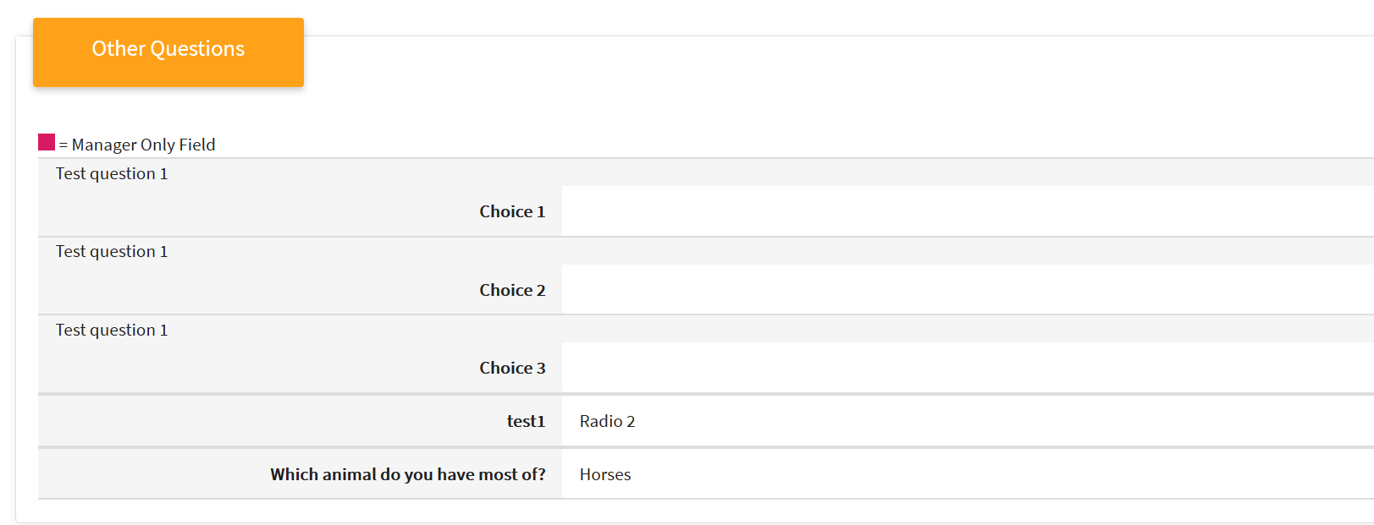  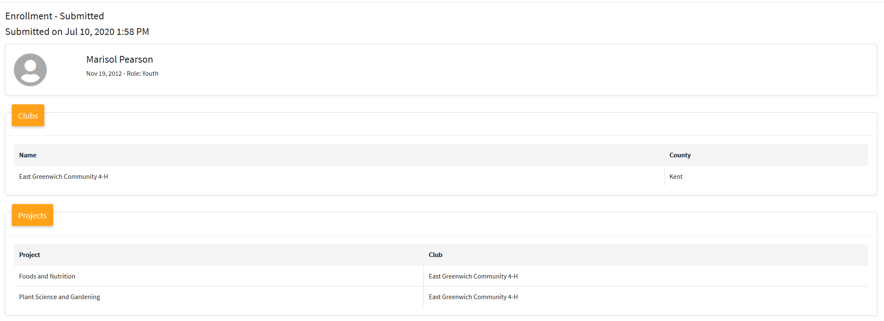

- To approve the member, at which time credit card transactions will be processed, click the Approve button.
NOTE: If the member is paying by check, their record will move to the Enrollments > Payment Due tab until the payment is recorded as received.
Tips
Do not approve the enrollment (send back to member) if:
- the invoice amount is incorrect. Send the enrollment back so that the invoice can be recalculated when the enrollment is re-submitted.
- any of the consents were incorrectly accepted or declined. Send back for corrections because once the enrollment is approved, the enrollment consents are locked for the remainder of the program year.
- the member role is incorrect. Send the enrollment back and delete it. When the member enrolls again, have them select the correct role, appropriate grade, etc.
Family discounts (if applicable) will show up after the appropriate number of enrollments in the family have already been approved for the program year.

