Sending Back/Deleting Non-Approved Enrollments
Before You Start
A manager must first send back the ‘awaiting review’ enrollment and then delete it. The family does not have an option to delete the enrollment.
Steps  - Click on the Enrollments tab in the navigation pane.  - Click on the Awaiting Review sub-tab.  - The screen will list all enrollments that have been submitted.  - Click on the member’s name to review their enrollment information. | Screenshots  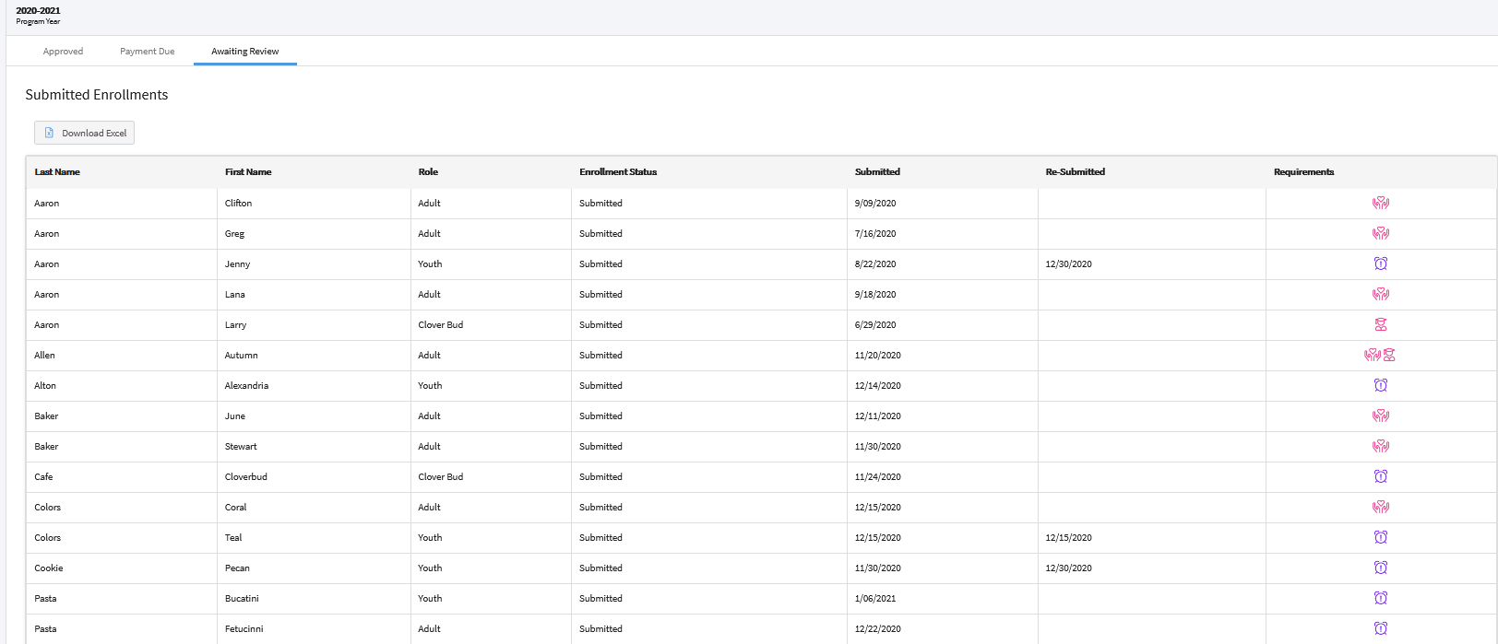  (Screen appearance may vary per state)
- The enrollment must first be returned to the family before the manager can delete it.  - Scroll to the bottom of the page.  - Please enter a comment for the user and click Send Back. The comment will be included in the email they receive to notify them that the enrollment has been returned. | 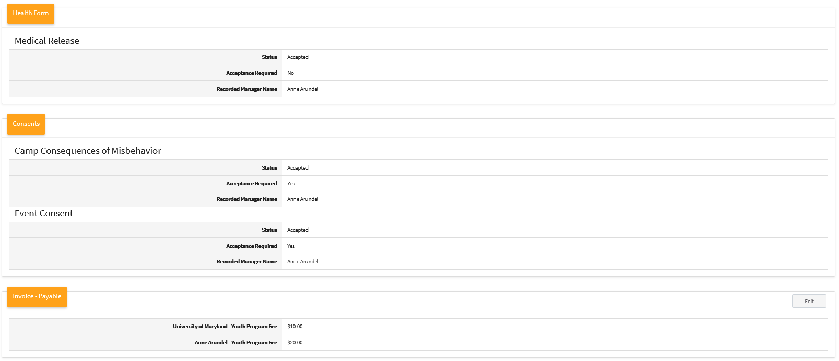  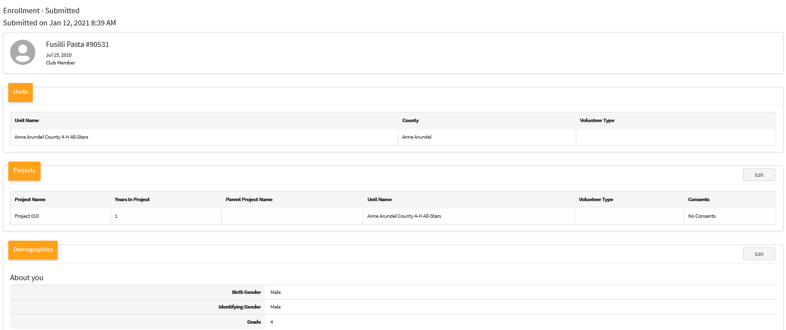
- Click on the Members tab in the navigation pane.  - Search for the member record that you have sent back and are ready to delete.  - Click on the member record. | 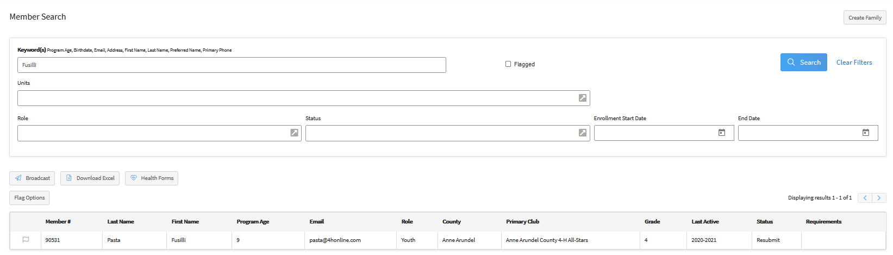

- Click Member List in the navigation pane. | 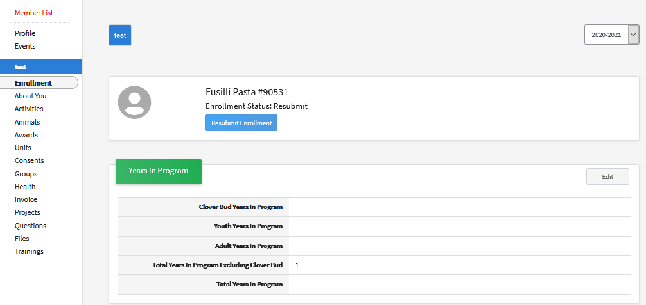
- Click Resubmit Enrollment next to the member’s name. | 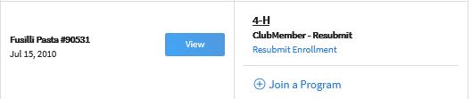
- Click the Delete button below the invoice information.  - A pop-up window will appear. Click Confirm to delete the enrollment. | 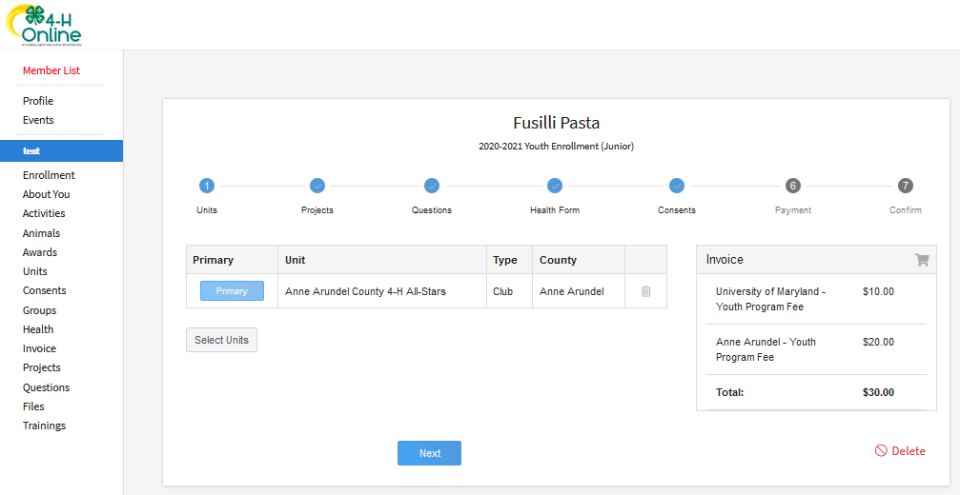  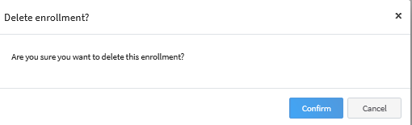
Tips
If the member has submitted enrollment with the incorrect role and it has not yet been approved, the steps above will remove the incorrect enrollment. The member can then enroll, using the correct role.

