Member Search
Before You Start
The Members section allows Institution and County Managers to search for members, view the member status, check on requirements that are not yet met, view the enrollment information and access family and member profiles. The Members search applies across all program years.

Steps  - Click on the Members tab in the navigation pane.  - You may enter a keyword and/or refine the search with filters for Counties, Units, Grade, Role, Status, Enrollment Date range.  - Click the Search button to find matching records.  - Click the Clear Filters link reset the filters. | Screenshots  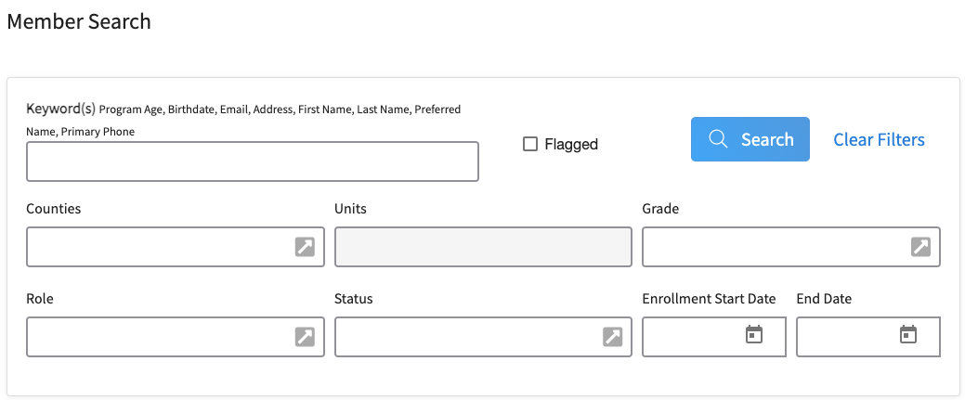  (Screen appearance may vary per state)
- The results will be displayed below the search area.  - The results will display 100 records at a time. Click the > button to view additional pages of results if applicable.  - Hover over the Requirements icon to see which requirements are not yet met. | 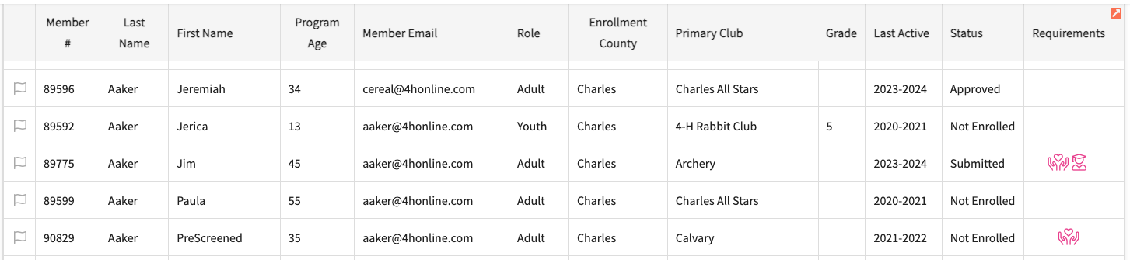
- At the top of the list of results, there are options for Broadcast (send an email to members listed on screen), Download Excel (download the information on screen as an Excel file), and Health Forms (Excel, PDF, Zip, or Audit file).  - You can also use the Flag Options to flag/unflag all results, and Customize a limited number of fields to appear on your search screen. | 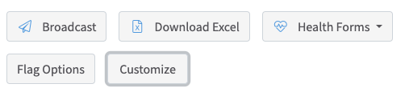
- Click on a Member to view the detailed member information, including Years in Program, Screenings, Trainings, Events, Units, and Projects. | 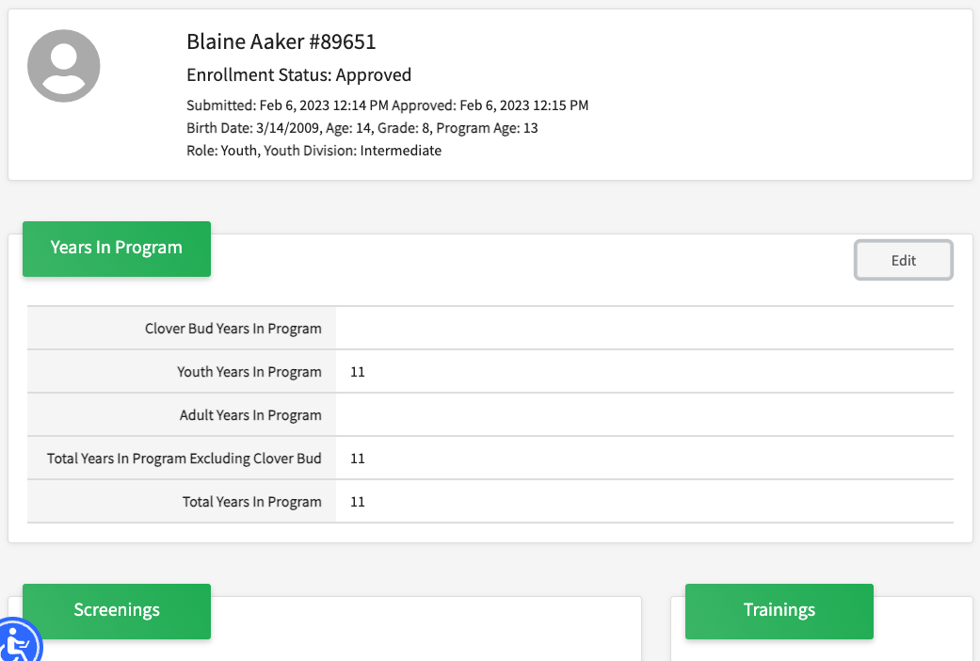
- Click on the Profile link in the Navigation pane to view Profile Notes, Profile, and Family Information.  Note: at the bottom of this screen are options to Dismiss, Archive, Mark Deceased and Delete the record. The options to dismiss or delete member profiles are restricted to Institution Managers. | 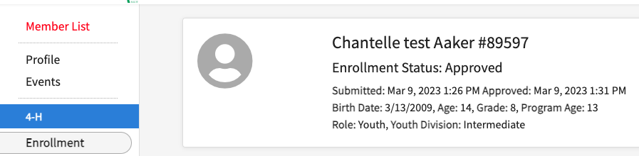
- Click on the Events link in the Navigation pane to view information about events for the member. | 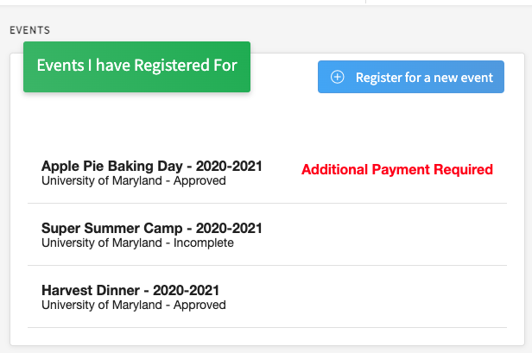
Tips
The member search filter for Counties is limited to Institution Managers. The program will restrict County Manager search results to members and families in the manager county.

